There needs to be more control.
Within Dashboard, Lead, Contact, Enquiry, Activity, Campaign, Feeds, Log and Survey the user should only be able view and create for Customers, Leads and Contacts that they have permission to
In Analytics Custom Charts the user should only be able to view Lead and Opportunities that they have permission
In Analytics Campaign Report the user should only be able to view Campaign information for Leads, Customers, Contacts that they have permission to

Segment Group should be part of Role Management permissions
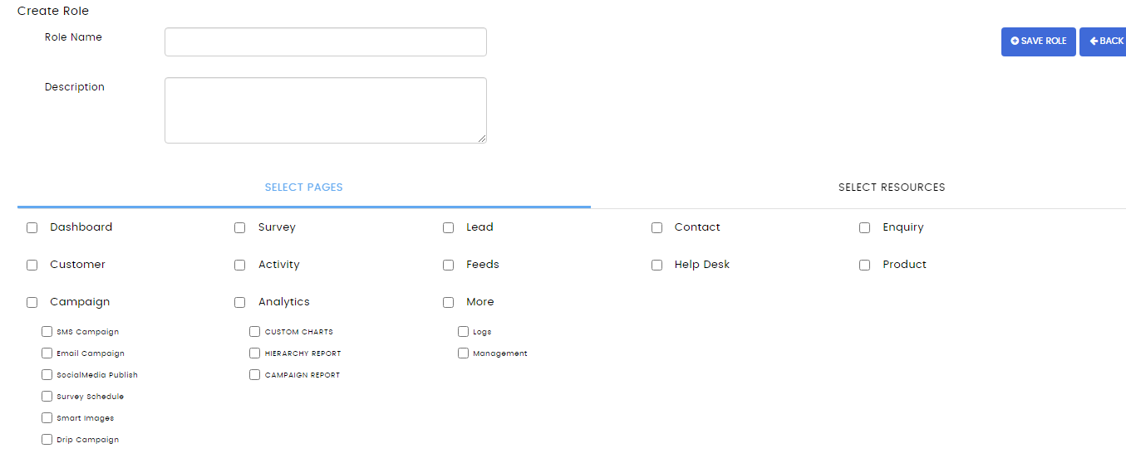

We need to be able to control permissions to the Settings section.
For example we may want a user to be able to change their password, but not have access to Segmentation, Field Customization, etc.
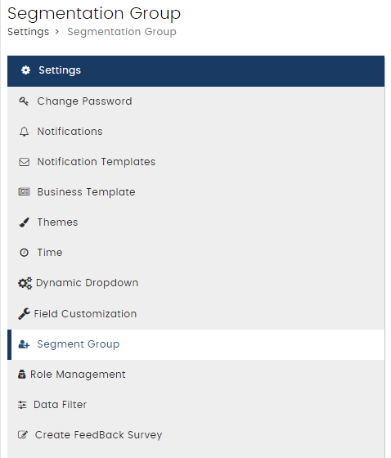

Need the ability to delete an Activity

Rename Enquiry to Opportunity

Is there a way to create additional fields in Survey outside of just the fields in the CRM?

